Please examine the program:  [SmartArrayUT2018done.zip](https://bc.instructure.com/files/115322370/download?wrap=1)

The code in the SmartArray class is a little bit different than the one I did in class, but not in any important way.

This code has a workding UnitTest project included.

[1] Figure out how to run the test and get the screen looking like this.

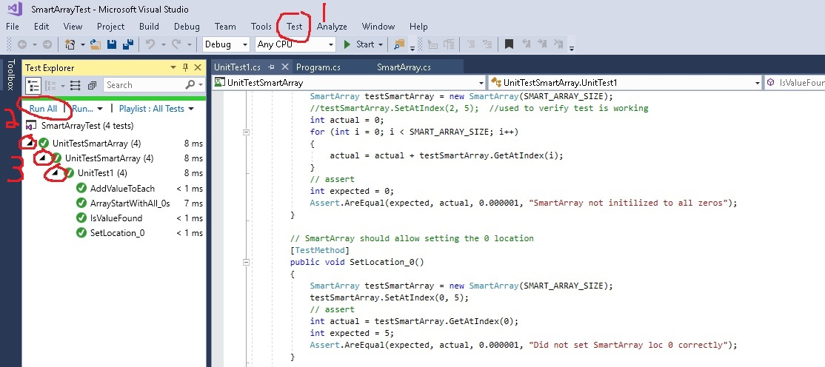

[2] If the Test Explorer Window is not open on the left, click on Test (1) and select “windows” and then “test explorer”

[3] Then click on Run All (2)

[4] Then expand all the little arrows (3) until you can see that all four tests ran successfully.

[5] These two test methods are not real test, you need to make them good tests:

public void AddValueToEach()

public void IsValueFound()

Note that if a test method does not have an Assert statement, then it cannot fail. That is why the test Explored is claiming that they all passed. You need to add code and an Assert statement to each of those methods and make them real test. Make sure they still pass. Then make a change that will cause them to fail, and run “all tests” and make sure they do fail.